**Forward**

Although in a historical sense fifty years is but a blink of an eye, for our Parish and its parishioners it is a testament to the vision, dedication and conviction of Faith to all of those who have been part of this journey. After such temporary places of worship in the beginning, to our current Parish Churches of Saint Anthony’s at Kingscliff and Saints Mary & Ambrose’s at Pottsville there has been much generosity and commitment to make this Parish an inclusive one that embraces all that Parish life has to offer.

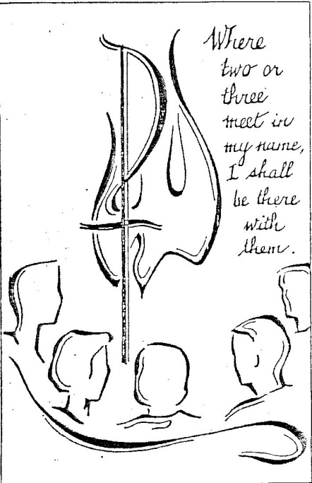A Parish is many things – a spiritual home for all, as well as somewhere our children can be educated, where we care for those in need, where we can make and keep new friendships, where we can deepen our personal Faith and participate in the various ministries of the Parish.

I hope that the following pages will revive memories for some and give a sense of understanding to newcomers of what has taken place over the last fifty years. The selfless giving of time and their precious memories and photos by all of those who contributed to the production of this booklet is much appreciated. May God continue to guide our decision making in the future to build on our first fifty years.

*Carmel Atkinson*

**In the beginning.....**

Kingscliff Parish was originally part of Tweed Heads Parish until Bishop Farrelly wrote to its then Parish Priest, Father Hanley, on 8 June 1955 asking him to purchase land for a Church at Kingscliff “as the growth anticipated in this area will require a Catholic Church in the near future”. On 17 January 1956 Father Hanley informed the Bishop that “he had signed a contract to purchase land at Kingscliff with a house on site measuring 66 feet by 165 feet. The purchase price was £1,550. The site is half a mile from Post Office and two and three quarter miles from Chinderah Church”.

On 24 March 1960 Bishop Farrelly wrote to Father Hanley indicating the decision “to cut off from Tweed Heads Parish all territory on the south side of the river and set up a new parochial district with Kingscliff at centre. This means that Fingal, Chinderah, Cudgen and Kingscliff would be taken from Tweed Heads Parish. The new Parish will include Tumbulgum. This new arrangement will come into force on 1 November 1960”. Father Eamon Leonard was appointed the first Parish Priest of Kingscliff on 27 November 1960.

From such rudimentary beginnings the Parish began to take shape. However, there was no Church or school at Kingscliff. Rather there was an option to buy two blocks of land from the local RSL right on the beachfront. An old army hut on site was where Mass in Kingscliff was celebrated for five and a half years awaiting the building of a new Church.

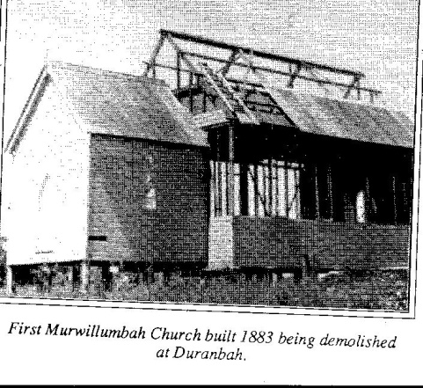St Francis’ Church built in Murwillumbah in 1883 had been first moved to Stott’s Creek and in the 1930’s on to Duranbah on Cudgen Road. Here Mass was celebrated once a month at 10.00am. November 1961 saw the last Mass held in this historic Church and shortly after it was demolished after the land on which it stood was sold.

*One of the only three photos in existence of St Francis Church*

*as it was being dismantled!*

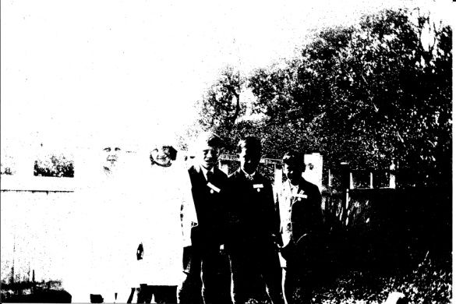St Mark’s Church at Chinderah was another of the small local Churches to have Mass each month. Father Hanley would arrive in his trusty little car nicknamed “the white ant” and conduct Mass to those who have travelled some distance to attend. The high percentage of children present could partly be explained by the distribution of chocolates at the end of Mass. Mass times were often flexible – depending whether the large families were on time or not. Since these were the days of fasting from midnight, only Father Hanley received Communion at Mass. He would return early on Monday morning to distribute Communionto the congregation.

*First Communion at St Mark’s 15 August,1933:*

*Mary Ord, Paul Kenny, Frank Sanotti, Roy Luxton*

Father Leonard set about making plans for Kingscliff Parish’s own Church. He suggested to the Bishop that it be named St Anthony’s and so the planning began. The architect for the Church was Mr J Toomey and a group of prominent parishioners were galvanised into raising money for the project. Spearheaded by Keith Pritchard a Parish Loyalty Dinner was organised for Sunday, 4 June 1961 to pledge to raise £9,000 over a three year period. Two hundred and fifty people attended the dinner at the RSL Hall in Kingscliff. In that three year period an enormous amount was achieved – the erection of Saint Anthony’s Church, purchase of land at Fingal and Chinderah, land and a house at Kingscliff, furnishing the Presbytery, payments of Diocesan interest, repayment of bank loan, operating expenses of the Parish were met as well as subsidy payment to the Presentation Sisters. Those early Church members were people of commitment and vision and set an excellent foundation for the continual growth and development of our Parish.

St Anthony’s Church was blessed in a ceremony conducted by His Lordship Bishop Farrelly on 17 December 1961 and for the Parish this was their first permanent place of worship.

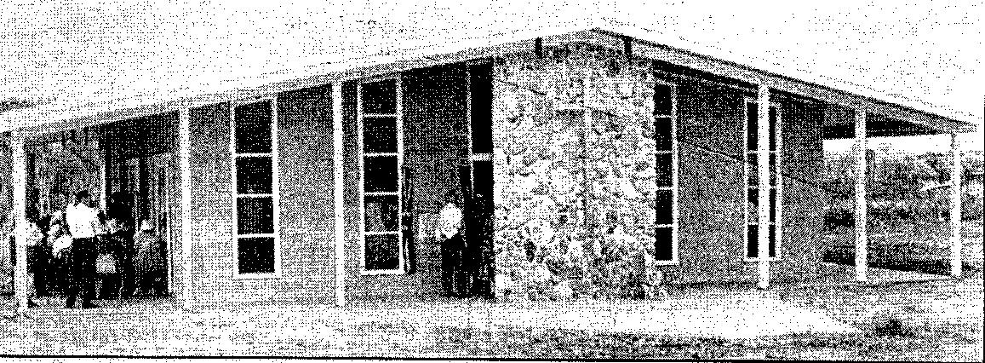

*The original St Anthony’s Church at Kingscliff*

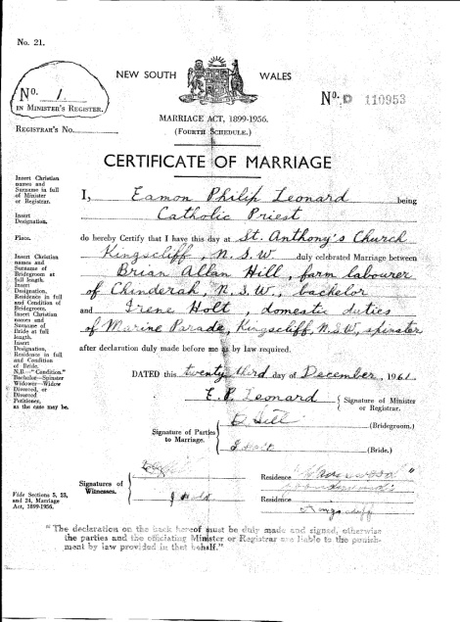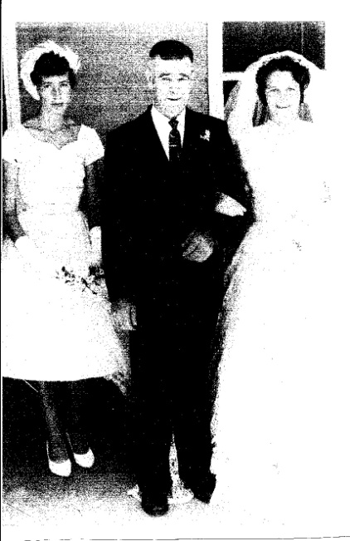The first wedding conducted in the new church was between Brian Hill from Chinderah and Irene Holt from Kingscliff. Their marriage took place on 23 December 1961 barely a week after its official opening. The couple (pictured) have recently returned to the Parish after several years living in other parts of the country.

The next project to be addressed was the provision of a Catholic School to educate the growing numbers of children now being part of the Parish. As was the practice then the school would be staffed by a religious order, in this instance the Presentation Sisters who would travel each day from Tumbulgum. The school opened with fifty one students in 1968 in the old Uki Convent School that had been transported to the new school site.

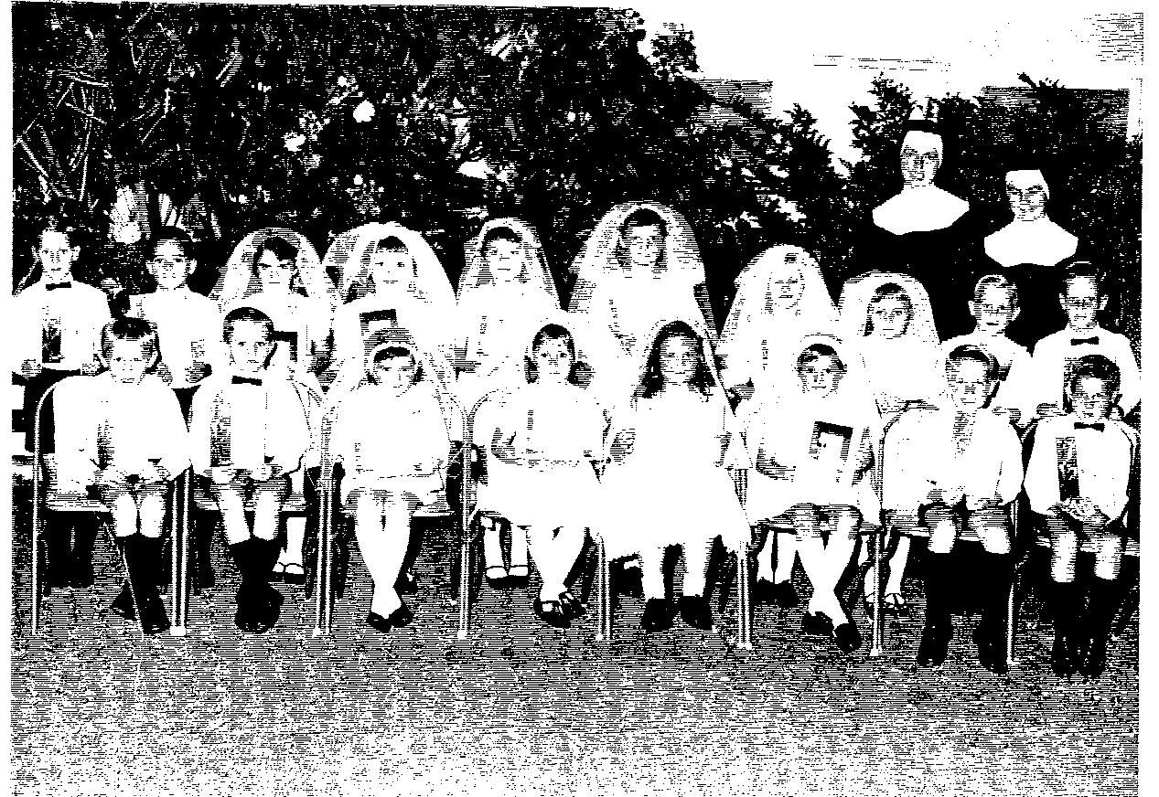

*The First Communion Class of 1969*

Father Leonard was transferred to South Lismore Parish in 1971 and Father Tom McEvoy was welcomed as his replacement. Father’s early years were spent in overseeing an increasing number of building projects on the school site. He was operating from the old presbytery (located where the school’s Pearl Street car park is) and his house-keeper, Kath Togo and her family lived in the house on the Church grounds (16 Pearl Street) whilst their home was being built. The need for a proper Presbytery became evident and so the logistics of selling the house and having it transported to its new location at Ferndale allowed the site to be cleared and the new Presbytery erected on its present site.

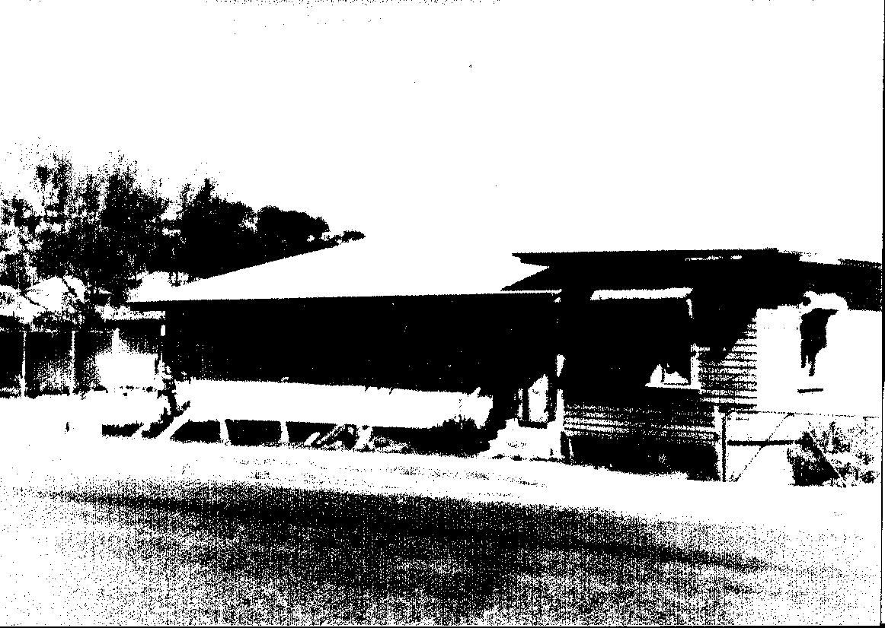

*16 Pearl Street, Kingscliff taken in October 1976 just before its removal*

The new Presbytery was officially blessed and opened by Bishop Satterthwaite on 21 April 1977. At last the site now contained a Church, a presbytery and a school.

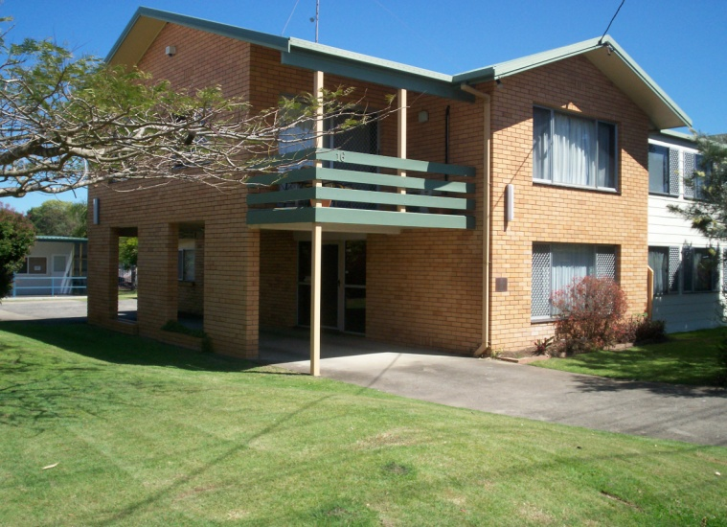Father McEvoy enjoyed working with all groups within the Parish. Many children spent countless hours being fed and entertained in his company. The local Rugby League team, the Cudgen Hornets usually only took the field after his

*The St Anthony’s Presbytery*

words of encouragement and blessing. Father was also fondly remembered by his cook ups to feed the homeless and the poor in the community.

Pottsville was added to Kingscliff Parish in 1977 so there was now an extra congregation to be looked after and planned for. The history of Pottsville’s journey towards their own Church is covered later on in the booklet. Their Church of Sts Mary & Ambrose was solemnly blessed by Bishop Satterthwaite on Sunday, 20 March 1983. This increase in the size of the Parish also meant an increase in number of children being enrolled at St Anthony’s School and so the building of new facilities to cope with these increases continued. These early Parish Priests certainly recognised the necessity of providing for all of the parish needs and had the support and encouragement of the community to back their plans and give financial support to the projects.

Father McEvoy retired in 1985 and continued to reside in the Parish. Whether he understood the term retired is a moot point as he continued to celebrate Mass in the Parish and participate in parish activities.

Father Gus Parker was appointed Parish Priest in 1985 built upon structures already established in the Parish. He instigated the Family Group program into the Parish as well as putting the proposition of establishing a St Vincent de Paul Conference at St Anthony’s. These ideas were warmly taken up by sections of the community and they continue to operate today. Father Gus also organised and participated in adult scripture groups where participants were encouraged to understand the bible, both New and Old Testament readings. The Rite of Christian Initiation of Adults (RCIA) program was another that Father Gus saw as a way of assisting those seeking to become members of the Church. For a time the Antioch Movement was also strong in the Parish. It provided an avenue for young people under the guidance of adults to enjoy and socialise with other Catholic youth.

But like all of his predecessors Father Gus realised another major construction was needed. The congregation had outgrown the original Church so a new Church was planned to replace it. Whilst it was being constructed Mass was again celebrated in temporary premises, namely the current School Hall site. The new Church of St Anthony’s was officially dedicated on 31 October 1993 at a ceremony lead by Bishop Satterthwaite. Like the original Church it was also a War Memorial Church.

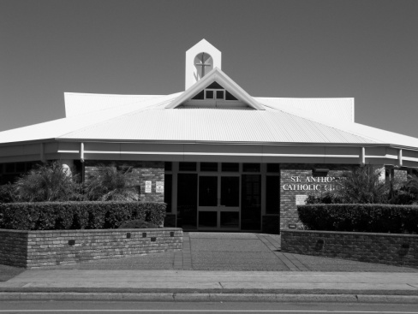Unfortunately, Father Gus Parker died not long after the opening of the new Church. He passed away whilst walking on the beach at Kingscliff on Shrove Tuesday, 15 February 1994. This was just a month away from his Golden Jubilee as a priest. His Concelebrated Mass was led by Bishop Satterthwaite with forty nine Diocesan Priests assisting. A crowd of six hundred mourners packed the Church to overflowing with the school children forming a guard of honour for the funeral procession.

Father Tom Chapman took over as Parish Priest in mid 1994. Father Anthony Casey who now is retired in the Parish filled in from Father Parker’s death until the appointment of Father Chapman. One of Father Chapman’s early initiatives was the establishment of the Sts Mary & Ambrose Friendship Group at Pottsville and it continues today offering a welcome to newcomers to the area. Perhaps the activity that most people associate with Father Chapman was bingo in the Parish Hall on Saturday nights. Bingo, run by the Ambulance, was set up in Father McEvoy’s time and continued during Father Parker’s years. However, it was now to be run by the Parish and also included operating on Thursdays at the Bowling Club and due large crowds.

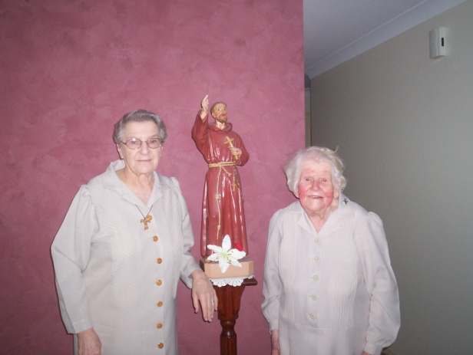Father Chapman, after discussions with the Franciscan Sisters, invited the order to work within the Parish at both Pottsville and Kingscliff. To this end two units were built on land donated by Father Leonard. One was used by Father as his retirement home and the other was to accommodate the nuns and their presence continues to this day.

*Sister Dawn and Sister Raymond near the statue of St Francis in their unit*

Sister Dawn and Sister Raymond moved in to the unit at Kingscliff on 18 December 2002 and their unit was blessed and officially opened on 2 March 2003. They carried out visitations in the Parish and Sister Dawn took the Eucharist to those unable to attend Mass. Both have now retired from active Parish duties but their presence at Parish activities ensures that they are still an important part of the community.

Father Jim Griffin was appointed to St Anthony’s as Parish Priest mid 2004. Like his predecessors more building on the school site was required to cater for the increase in enrolments. More demands were placed on schools to implement essential technological changes to stay abreast of curriculum requirements. With the extensions under the BER program the Parish can now be proud of its well equipped school. With an enrolment of three hundred and fifty students strategic use of its playground it can provide a wonderful opportunity for the complete education of its students.

As the Parish now consists of Fingal, Chinderah, Kingscliff, Cudgen, Duranbah, Casuarina, Bogangar, Hastings Point, Cabarita, Pottsville and Wooyung some rearrangement of Mass and Reconciliation times needed to be made. After consultation with the parishioners the number of weekend Masses was reduced to three with a Saturday evening Mass at Kingscliff, an early Sunday morning Mass at Pottsville and a later morning Mass at Kingscliff.

Some of the other changes that Father Jim has introduced are more related to pastoral matters. There has been a continual increase in the number of Baptisms within the Parish over the years and the flexibility in arranging suitable times for all parties has assisted. When it is during the celebration of Mass the whole congregation can welcome the newcomers into the Parish. The option for the family to decide at what Mass their child will receive the Eucharist for the first time within the month of August allows the child to sit with their family and extended family for this important occasion. The whole group then celebrates with a gathering after Sunday Mass at the end of the Mass.

During Father Jim’s time there have been several Parish dinners organised. This has allowed parishioners to mingle in an informal way with members of the Parish that they may not normally see if they are creatures of habit and attend the same Mass each week. They also allowed for parishioners from Pottsville and Kingscliff Churches to enjoy each others company. Several local businesses have supported these functions by supplying suitable raffle prizes.

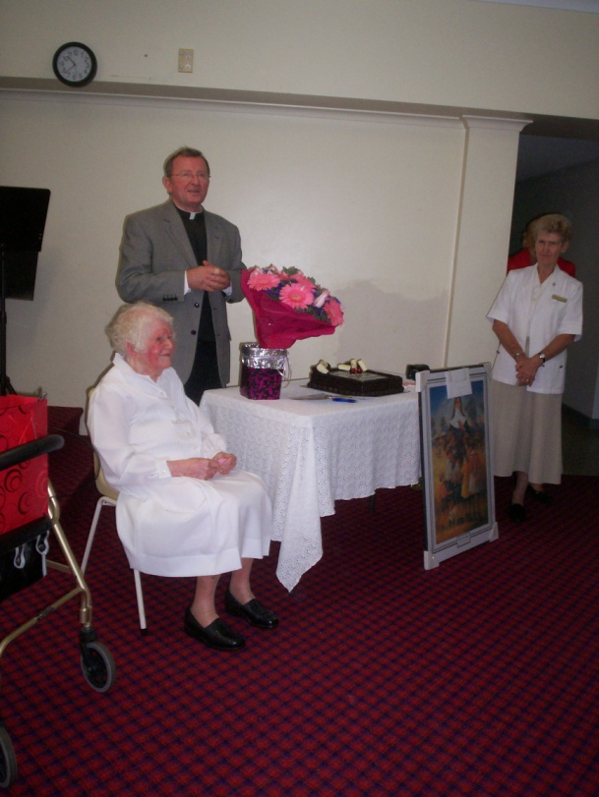Our Parish also enjoyed hosting overseas visitors for World Youth Day in July 2008. A group from the Solomon Islands spent time in the Parish prior to attending activities in Sydney. Several families hosted the young people and organised some outings of local sites during their visit. A particular memorable occasion was a Saturday evening Mass at which the visitors played guitars and sang during the Mass. One of these young men has since been ordained as a priest and still maintains contact with his host family.

The Parish organ finally produced its last note and so Father Jim set about seeking a suitable replacement. Given the location of the Church so close to the sea it was important it be resistant to corrosion and have appropriate speaker locations so that quality sound could be heard throughout the Church. It was an obvious time to relocate the organ at the back of the Church as well as to try to form a Parish Choir. A shortage of organists has meant the fledgling choir has not yet reached its full potential but as they say, “from little things big things grow”.

*Sister Raymond, Fr Jim and Sister Pauline, the Franciscan Provincial at the 100th birthday presentation in the Parish Hall in September 2011*

The most recent changes to the Parish have been the conversion of the school demountable buildings into much needed office space. The first building now consists of a meeting room with kitchen facilities and a toilet. This allows many Parish groups to hold their regular meetings in comfortable surroundings. The second demountable has been converted into an office for Father Jim and a separate office for the Parish Secretary and Parish Manager. This has enabled the Presbytery to now be able to provide the normal facilities and allow Father Jim to have privacy in his own living quarters.

**History of Pottsville Church**

Pottsville was part of Sacred Heart Murwillumbah Parish until 1955 and was then transferred to St Joseph’s South Murwillumbah. In 1977 is became part of St Anthony’s Kingscliff Parish.

Prior to 1919 Mass was celebrated in the Cudgera Hall. From 1919 Mass was celebrated in the home of Mary and Louis Murnane at their home in Cudgera. Following Louis’ death Mary married Ambrose Brown and Mass continued to be celebrated here until late in the 1940’s.

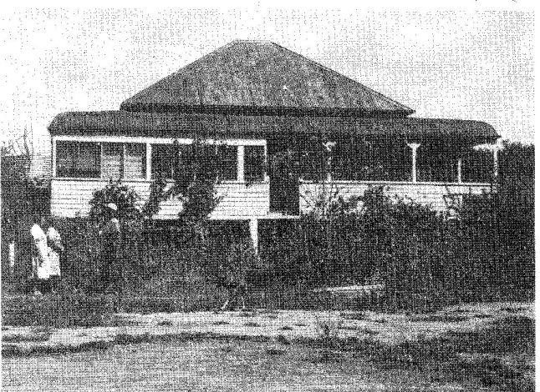

*The Murnane and Brown home*

Due to growth in the area `The Shed’ was acquired to hold Mass. It later became a shelter used in the Ambrose Brown Park.

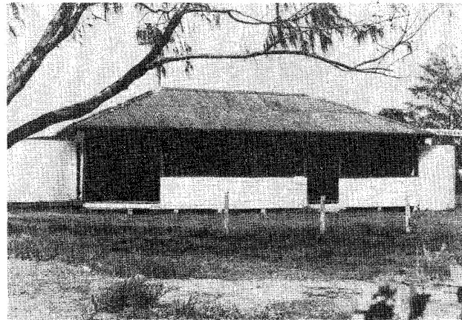 *The Shed*

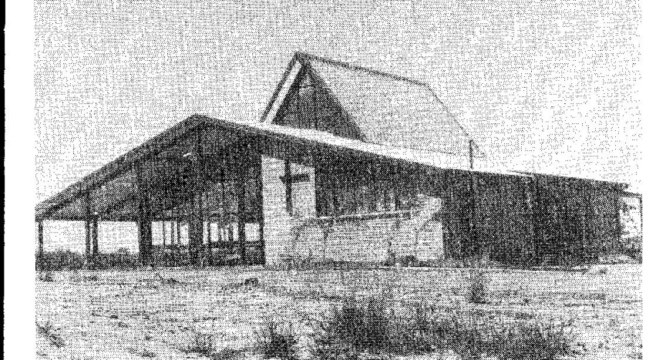Mary and Ambrose Brown foresaw the need for a Church and donated an area of land for that purpose. The present Church was built on this land in 1983 and named Saint Mary and Ambrose in honour of its benefactors.

*Saints Mary and Ambrose Church, Pottsville*

The Solemn Blessing of the Church occurred on Sunday, 20 March 1983 with a Concelebrated Mass by the Bishop of Lismore, the Most Reverend John Satterthwaite together with the Parish Priest, Father Tom McEvoy and other priests from the Diocese.

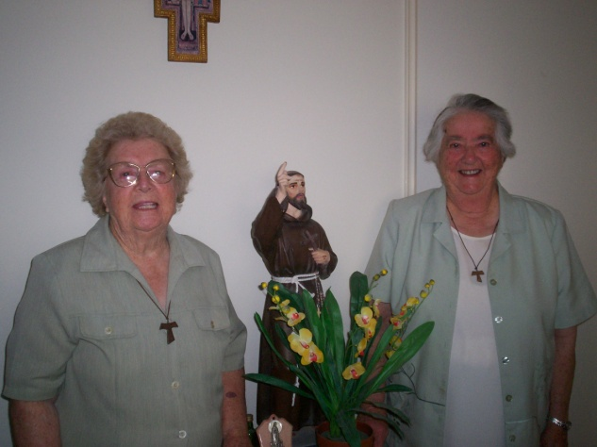In 1996 the Franciscan Sisters Mary Lucy and Mary José took up residence at the units in Pottsville that were constructed during Father Chapman’s time. They undertook a program of home visits and distribution of the Eucharist to those unable to attend Mass. After a year Sister José was replaced by Sister Miriam then followed Sister Catherine. Sister Quentin arrived in Pottsville in 1997 and continues her work there today with Sister Carmel. Despite being at an age where most of the rest of us have retired they continue with home visitations and taking the Eucharist to the Retirement Village at Sea Breeze. Both of the Sisters also provide a TeleCross service run by Red Cross whereby they ring daily those living alone to check they are alright and provide a friendly ear to listen.

**Our Spiritual Leaders**

**Parish Priests**

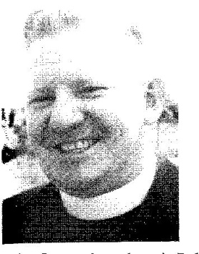

Father Eamon Leonard

November 1960 – December 1971



Father Tom McEvoy

December 1971 – May1985

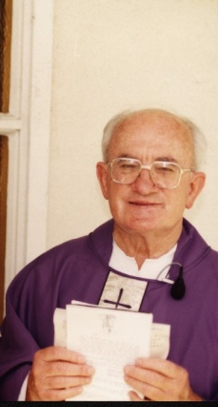

Father Gus Parker

May 1985 – February 1994

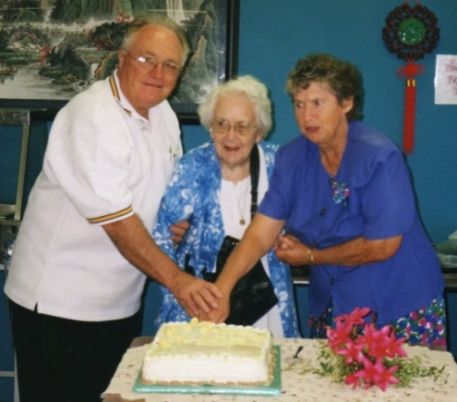

Father Tom Chapman

May 1994 – July 2004

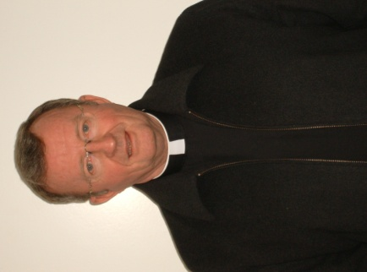

Father Jim Griffin

From August 2004

Current Parish Priest

**Education**

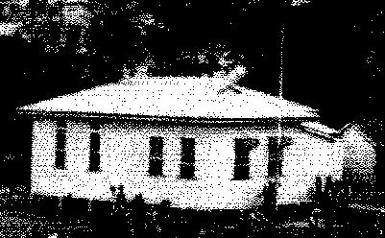In 1968, at the instigation of Parish Priest, Father Leonard and the Presentation Sisters, St Anthony’s School opened with 51 pupils housed in the original Uki Convent School, which was brought to Kingscliff by road. Foundation Principal was Sister Margaret Mazza and she and the other Sisters travelled first from Tumbulgum then later on fromTweed Heads.

*The Uki Convent School*

The Principals who followed were Sister Agnes Gaghan, Sister Maria Thomas, all Presentation Sisters who continued to staff the school until 1980. Since then the school has been under the leadership of a lay principal and staffed by lay teachers.

Paul Hookway was the first lay Principal appointed and he remained in the position from 1980 until 1992. Robert Lewis replaced Paul in 1993 and held the position until 1999. Michelle Campbell was Principal from 2000 until 2009.Tony Boyle was Acting Principal for the 2010 school year until a new Principal, Lynne Pull was appointed at the beginning of the 2011 school year.

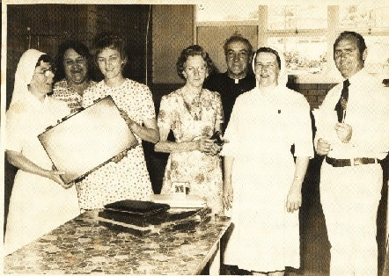

*Farewell to the Presentation Sisters*

*L-R Sister Elizabeth, Emily Buxton, Coralie Fisher, Fielda Windley, Father McEvoy, Sister Agnes Mary, Alan McIntosh.*

|  |  |
| --- | --- |
| The     In 1969, two new classrooms, a shelter area, tuckshop and student amenities were opened by Bishop Farrelly. As the school continued to grow, additional accommodation was provided in 1974, again in 1981 with two classrooms and administration facilities being added and again in 1983 when  *Father McEvoy in front of the 1974 constructions*  the old Cudgen Public School was purchased and moved into the site. During the years, enrolment numbers grew from the original 51 pupils to approximately 200 students. This necessitated the extension of three classrooms, toilet block and shelter area which were completed in 1989 and opened by Bishop Satterthwaite.  http://www.kngplism.catholic.edu.au/media/Pictures/shed.jpgFurther extensions to the library, and attached classrooms were made in the early 1990’s, with the tuckshop and administration refurbishment as well. The under-covered learning area – the Cola had its original construction in 2000. More additions were made in 2006.  The global movement towards Technology and computer assisted learning has also meant the introduction of Information Technology Education for students and the establishment of a networked Technology Centre. The introduction of interactive whiteboards in 2006 has seen St Anthony's continuing to provide state of the art facilities to maximise student learning outcomes.  http://www.kngplism.catholic.edu.au/media/Pictures/frmac1.jpgFurther increase in enrolments led to the establishment of using three demountable buildings as temporary classrooms in 2005. The demountable rooms are now being utilised by the Parish for a meeting room, the Parish Office and Father Jim’s Office.  Finally the new classrooms were ready for the commencement of the school year in 2005.  http://www.kngplism.catholic.edu.au/media/Pictures/MVC-002S.JPGhttp://www.kngplism.catholic.edu.au/media/Pictures/MVC-002S.JPGIn 2010 work commenced on the building of specialist rooms under the Federal Government’s Building the Education Revolution (BER) and these amenities were opened in July 2011. *2005 Extensions* | |
| http://www.kngplism.catholic.edu.au/media/ber/2011/IMG_2463.JPGhttp://www.kngplism.catholic.edu.au/media/ber/2011/IMG_2458.JPG | |
| *Some of the new classrooms provided for from the BER grant.*  **The School Logo**  http://www.kngplism.catholic.edu.au/media/Pictures/Colour%20Logo.JPGThe School logo designed in 2003 by Michelle Campbell is distinctive in design and symbolises the school’s location as represented by the Cudgen pine trees, the yellow sand and the blue for the sea, but with the overriding Christian symbol, the cross. It’s motto, *“Love and Service”* portrays the values being passed on to its students.  **Family groups in Saint Anthony’s Parish, Kingscliff**  Early in 1989 Father Parker approached Andrew and Robyn Denny about being co-ordinators for the Passionist inspired Family Group Movement founded by Father Peter McGrath in Terry Hills, Sydney some years before.  robyn.jpgRobyn and Andrew (pictured) took on the challenge and Father Tim Horlock from Brisbane came and outlined the procedure for setting up Family Groups in a parish. Assisting him in this task were the Byron Bay Coordinators. Father Parker and Father Tim asked the Denny's to review the Parish Register and phone people, (many they had never met before), and invite them to a casserole night at their place with a view to becoming leaders of a group. This was to be a shared meal, with families bringing a casserole and drinks. The result was people ended up meeting parishioners they never even knew existed. At that first casserole night, there were seven couples and their children: Andrew and Robyn Denny, Hugh and Iris Azzopardi, Kath and Frank Cherry, John and Margaret Fletcher, Graeme and Janet Blandford, Mike and Jo Hortle and Steven and Mandy Tate.  On that night, the concepts and aims of the Family Group Movement were explained – as well as being a spiritual movement, it was to be a social one, aiming to bring parishioners: children, singles (unmarried, widowed, divorced), young married couples, older married couples, grandparents and non Catholic folk who would like to attend the functions (husbands, wives, parents, children etc) together, regardless of one's geographical location in the parish. The cost of outings and get-togethers were to be kept to a minimum – once a month. The planning could be that one month was a daytime activity and the next month, perhaps an evening event.  The Byron Bay coordinators spoke at the Kingscliff and Pottsville Masses and many parishioners filled out the necessary form and from there the groups were formed. It was stressed that the Leaders would not make the decisions – decisions were and still are always made by the group in terms of outings and events. And so began a time of much parish social activity within the Family Groups including: casserole nights, BBQ's, themed nights, games nights, progressive dinners, Australia Day breakfasts, Christmas parties, Family Group Masses and morning teas, car rallies, annual camps, Mother's Day remembrances and St Patrick Day celebrations.  The spirituality of the Family Group members shone through when help was needed to those going through difficult or unfortunate circumstances. Regular leaders meetings were held and leaders attended a diocesan leaders’ conference once a year, as did the coordinators. Father Brian Traynor and Father Paul Traynor replaced Father Tim, who was transferred to Adelaide. They became mentors for the diocesan coordinators and leaders alike and ran helpful workshops. Each family group was also encouraged to hold a weekend away once a year.  *A typical Family Group picnic*  picnic.jpgOver time, parishioners moved, children grew up and the numbers in the groups dwindled, so that in the mid 1990's the groups were amalgamated into four. In recent years, the groups numbered two – the Cherry Family group and the St Anthony's Family Group and quite recently another grouphas been formed, the Ocean Spirit Family Group whose members have agreed to have the leadership of the group as a rotational role.  From 1989, the coordinators were Andrew and Robyn Denny while in 1998 Alison and Robert Lewis took over the reins. Other leaders, apart from those mentioned already are: Phillip and Marion Gardner, Peter Byrne and Barbara Schiller. At the moment there is no coordinator of the Kingscliff Family groups but Kathy Cherry has kindly offered to be the chief communicator between the Kingscliff Family Groups and the Passionist Fathers. The Family Group movement is an ongoing one that continues to aim to bring communities together.  **Legion of Mary**  legion.jpgThe Legion of Mary, a lay Catholic organisation whose members are giving service to the church on a voluntary basis, was in existence when Kingscliff was part of Tweed Heads Parish and had active members in 1951. Father Leonard had a strong devotionto Our Lady and *Members of the Legion of Mary* the Legion of Mary was quickly established at Saint Anthony’s. The object of the Legion of Mary is the glory of God through the holiness of its members developed by prayer and active co-operation in Mary's and the Church’s work. Since its inception the Legion has continued with its weekly meetings and its members participate in the life of the parish through visitation of families, the sick, both in their homes and in hospitals.  **Saint Vincent de Paul**  http://www.kngplism.catholic.edu.au/media/Pictures/frparker1.jpgIn the late nineteen eighties Father Gus Parker invited members of the Tweed Heads Conference of the Saint Vincent de Paul Society to address the parishioners of St Anthony’s with the view of starting up its own Conference. At this meeting the philosophy of the organisation was outlined, namely that of a lay Catholic organisation that aspires to live the gospel message by serving Christ in the poor with love, respect, justice, hope and joy, and by working to shape a more just and compassionate society. The St Vincent de Paul Society aspires to be recognised as a caring Catholic charity offering “a hand up” to people in need. It does this by respecting their dignity, sharing our hope, and encouraging them to take control of their own destiny.  *Father Gus Parker*  After discussion and a willingness to proceed the fledgling Conference was set up under its inaugural President, Hugh Azzopardi, and so began its regular meetings and exchange of information that allowed the Society to fulfil its Charter. The opening of the Charity Shop and staffing of it followed. Today the Society continues its work and over the last few years despite falling numbers has been able to initiate the Family Christmas Hampers with strong support from the parish community. The members of the Society meet every second and fourth Friday of the month in the Parish Meeting Room and would welcome new members.JTEUNOV1510  **St Mary & St Ambrose Friendship Group**  C:\Users\Carmel\AppData\Local\Microsoft\Windows\Temporary Internet Files\Content.Word\Father Tom Chapman, Marie Smyth, Val Murphy..jpgThis was an initiative of members of the Pottsville part of the Parish during Father Tom Chapman’s time as Parish Priest. With a number of newcomers settling in the area, particularly retirees or young families without family or friends support, a group of residents wanted to offer the hand of friendship and support to allow these new arrivals to settle into the community*. Father Tom Chapman, Marie Smyth and Val Murphy*  The group was established in 1995 and was non denominational. The original chairperson was Marlene Condon and the group met on the first Monday of each month. Support in the form of visits, organisation of social functions or simply just providing transport for hospital visits, meals for faC:\Users\Carmel\AppData\Local\Microsoft\Windows\Temporary Internet Files\Content.Outlook\RTBRMDX4\Judy Ward Joan Edwards Lexie Wilson.jpgmilies overcome by sickness. Using the Prayer to Saint Francis as its guide this group filled a real need in the community.  *Judy Ward, Joan Edwards and Lexie Wilson at a group function* | |

**The Catechists**

As the Parish grew with the increase in families settling in the area, Father McEvoy recognised the need for the Catholic children attending State schools to receive information about their Faith through the Catechist program. Mary Kenny and Molly Anderson were asked by Father around 1978 to visit Kingscliff Primary School and teach the twenty five to thirty students enrolled there. With little formal training or structured curriculum they shared their knowledge and encouraged the children to practise their faith and prepared the children for the reception of the Sacraments. Other members were added to the team as the numbers increased.

Cudgen Public School was the next school to join the program. A small core of committed parishioners managed to staff all the classes requiring a catechist. An organised program was developed and newcomers to the program were in-serviced and supplied with program guidelines.

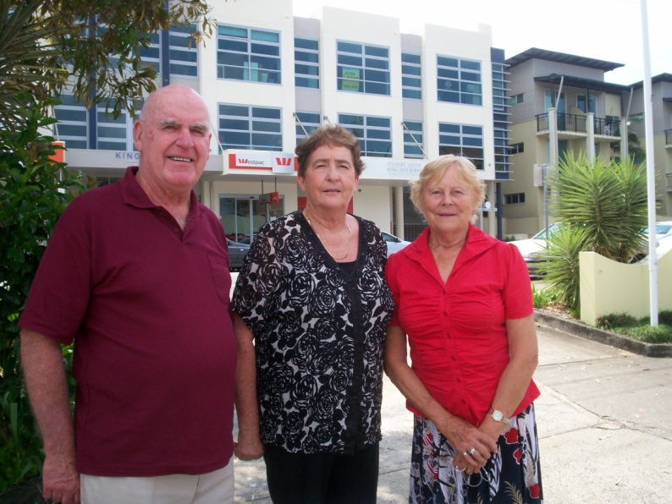With the increase in population in our Parish due to the inclusion of Pottsville, it was necessary for Pottsville Primary School to become part of the program. Parishioners in that area were called upon to help to cover the classes needing assistance. The longevity of some of these catechists is to be admired.

*Catechists Mick Murray, Clare Perkins and Marion Gardner*

Their dedication to duty and their love of the job has allowed the program to continue to exist at the same time catering for an ever increasing number of students. The opening at the new school at Bogangar has put a further strain on the resources, but not one that has not been able to cope.

The current list of catechists number eleven with two reserves and this is to provide a service in each of the local four Public Schools.

**Papal Blessings**

Four of our parishioners are recipients of Papal Blessings for their generous service to parish life. The *Croce Pro Ecclesia et Pontiface* is an award consisting of a framed certificate, a cross and a medallion that is presented to Catholics for their services to the Church and to the Pope. There are very few recipients of this prestigious award and to have five within this relatively young Parish is a testament to the calibre of spirit and willingness to contribute by its parishioners.

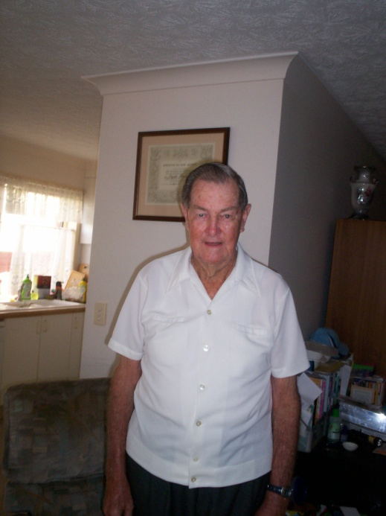**Keith Pritchard** was presented with his Blessing (behind him in the photograph) in 2006 for his personal involvement in Parish finances since the inception of the Parish. His initial work in securing the finances for the building of the original Church by organising the Parish Loyalty Dinner attended by two hundred and fifty guests resulted in pledges being taken to raise the money necessary for the establishment of all the physical structures required for a parish to function. In the early years Keith and a couple of parishioners used to count the money on the morning after the weekend Masses. Keith kept his focus on maintaining a secure financial basis for the Parish and served on the Parish Finance Committee until his retirement from the Committee last year – a fifty year commitment to the Parish.

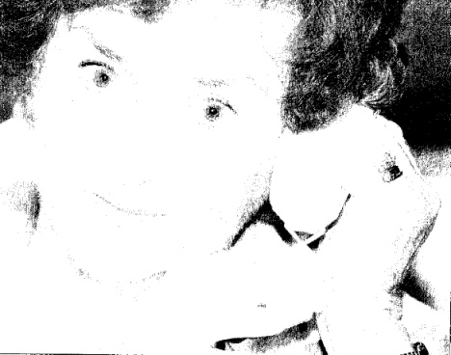**Clare Ahrens** received her Blessing at Saturday evening Mass on 5 February 2005 by Bishop Jeffrey Jarrett. She had been nominated by Parish Priest Father Jim Griffin in recognition of her forty three years service to playing the organ in the Parish at all Kingscliff Masses during that time. What started out as a fill in position as the current organist had broken her arm, became a full time commitment until she finally retired in 2004.This was a great dedication to the Parish needs and provided the musical component of liturgical services that allows more meaningful participation by the congregation in weekend Masses. On occasions she also filled in at Pottsville Church if needed.

**Frances McMahon** was another of those quietly working in the background to support parish life. For a number of years she organised and sold items in the piety stall. Frances also was a catechist for many years providing her knowledge and love of her faith to children at Kingscliff Public School. As a 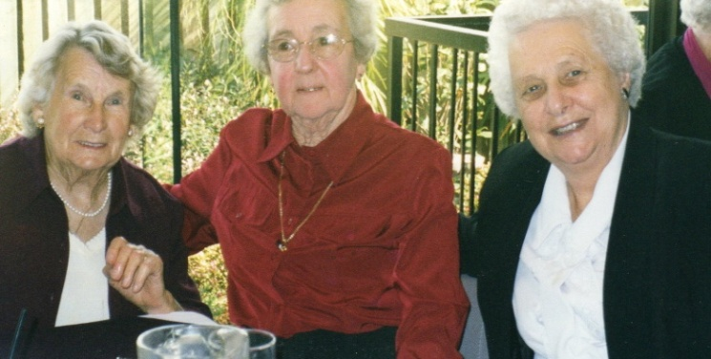member of the Friendship Group she was at hand to help and support members of the community. Her devotion to Mary ensured that she was a regular attendee at meetings and functions organised by the Legion of Mary. Frances received her Papal Blessing from Father Jim Griffin in 2006 at Sunday Mass.

**Catherine Winn** was involved in all aspects of sacristy work for many years. She fulfilled these duties and assisted the Parish Priests to enable everything to be ready in place so that Mass could proceed smoothly and afterwards ensured that all was set up for the following Mass. Kath was appointed as a Special Minister of the Eucharist and was meticulous in her attendance whenever rostered. She gave the same commitment to her catechist duties and carried out these duties at Cudgen and Kingscliff Public Schools for many years. Kath now resides in Brisbane but her contribution to our Parish was acknowledged when she was presented with her Papal Blessing at Sunday Mass in 2006.



**Father Tom McEvoy** received his award for seventy years service as a Priest in the Lismore Diocese. He was presented with his award by Father Jim Griffin in 2006 at Sunday Mass. His contribution to our Parish both in pastoral care and construction work will not be forgotten. After Father Tom retired from active parish duties he continued to live in the Parish until his death in July, 2007.

**Acknowledgements**

Many parishioners have contributed to the contents of this booklet, some by sharing their memories orally, others by sharing their photographs and other memorabilia. There is very little concrete archival material available so that not all information can be verified. However, whilst we all may remember things slightly differently when recorded by others, every attempt has been made to present this brief history as accurately as possible. If there are mistakes they were not intentionally made and I apologise for them.

I appreciate all the help, advice and patience given me by all the contributors. The list of names would fill several pages and I do not want to miss out anybody, so please each and every one who has contributed please accept my appreciation for all your assistance.

Thank you to Father Jim Griffin, Parish Priest, for his support of the project. History is a wonderful teacher and the past fifty years have shown us what can be achieved when a community works together with a common purpose. The next fifty years will bring major changes and challenges. We have a very good foundation to build on and we have the people who can bring all those plans to fruition. Let us enjoy the journey!

Carmel Atkinson

